S.C.O.R.E. Course Scheduling User Manual

By: Will Crawford
Sabba Petri
Eric Stegall
Benjamin Ross
Justin Lazaro
Table of Contents
General Overview 1
1.0 Learning the Application 1
1.1 System Overview 1
1.2 Definitions 2
1.3 System Requirements 2
Getting Started 4
2.0 Accessing the Application 4
2.1 Connecting to Application (All Users) 4
2.2 Program Administrator 5
2.3 Program Manager 7
2.4 Lecturer 8
2.4 Student 10

Getting Started

System Overview, Definitions, System Requirements


1.0 Learning the Application

1.1 System Overview
The MyCourses Scheduling System will allow program administrators, program managers, lecturers, and students to create, assign, detail, and sign up for courses.
The purpose of this application is to provide a mechanism for departments to submit updates, additions or deletions via the web for future course offerings, and allow aggressive control for each user of the system. MyCourses replaces the paper-based process, which was cumbersome, and brings the entire system online.
With consideration to each user, the program administrator will provide the constraints by listing the possible courses, times, and locations, while the program manager designates and determines which courses and lecturers will be offered for that particular quarter/semester. The lecturer takes the role of filling out the constraints and information about the course and lastly, the student signs up for the courses they desire.
From within this end-to-end system, there is an incorporated algorithm that performs the function of automatically scheduling courses, based on a list of constraints provided by the user. The system then parses these constraints and supplies a list of categorized classes for the user to handle at their discretion.
The architecture of this scheduling system provides for a powerful two-tiered system: a web server based on Django, and a genetic algorithm based on Python. While Django supplies an abstracted framework for dynamic websites, Python is portable, highly scalable, and strongly stable.
MyCourses also provides a strongly intuitive user interface, varying for each user of the system. The minimalist design helps bring the most important functions forward for the user, while its feature-heavy structure allows for stronger power. This combination of style and power brings about an instinctive attraction to any user of the system.

1.2 Definitions
- MyCourses – The end-to-end course scheduling system.
- PA (Program Administrator) – User handling the entire MyCourses system.
- PM (Program Manager) – User handling each individual department’s program and course offerings.
- Quarter/Semester Course List – This will be a list of courses to be offered in any particular quarter/semester, provided that each quarter be unique and independent from other quarters/semesters.
- MyPortal – This is the main user interface (on the web browser) that each user will be interacting with.
- Users – Users can be considered any user of the MyCourses system.

1.3 System Requirements
- PC/Mac Requirements:
  - Any machine with an Internet connection is required. A printer with the capability of printing schedules and web pages is optional.

- Software Requirements:
  - Internet Explorer, Mozilla Firefox, Google Chrome, Apple Safari, and most browsers are compatible with MyCourses. Latest version of each browser is recommended for optimal viewing, yet not required.

Getting Started

Connecting to Application, Program Administrator, Program Manager,

Lecturer, Student

2.0 Accessing the Application
Overview:
The S.C.O.R.E. Scheduling System will be executed through following sequence:
- Step 1: The Program Administrator will designate all of the possible courses, times, and locations and then submit that information down to the Program Manager.
- Step 2: The Program Manager then determines which courses and lecturers are offered in the particular quarter/semester and with this information, releases the information down to the Lecturer.
- Step 3: The Lecturer fills out the constraints and information about their course, which is then sent back to the Program Manager for acceptance. The Program Manager sends the department information to the Program Administrator and once accepted, the Program Manager accepts the Lecturer’s preferences. Once accepted by the Program Administrator, the course schedule is then released to the Student.
- Step 4: Finally, the information is presented to the Student, who can then sign up for their classes.

2.1 Connecting to Application (All Users)
In your browser, type in the URL provided by your institution.
The Welcome page will appear. Once connected to the site, you may then save it by using the “Favorites” or “Bookmarks” drop down menu, often located at the top of the toolbar of the browser. By doing this, it will eliminate the need to retype the URL every time the user returns to the page.
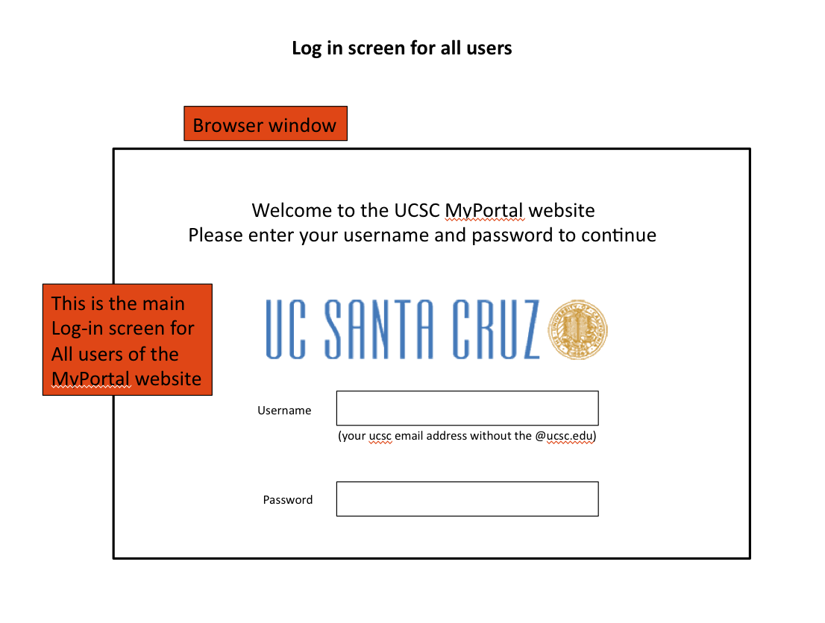
Figure 1

- Once the screen appears, the user has the ability to enter their credentials to gain access to MyPortal. Each user affiliated with the institution system will have a specific username and password for access.
- If a user does not have a username or password, they should contact the institution to gain access privileges.
- After inputting credentials, click on [soon to be] Login button.

2.2 Program Administrator
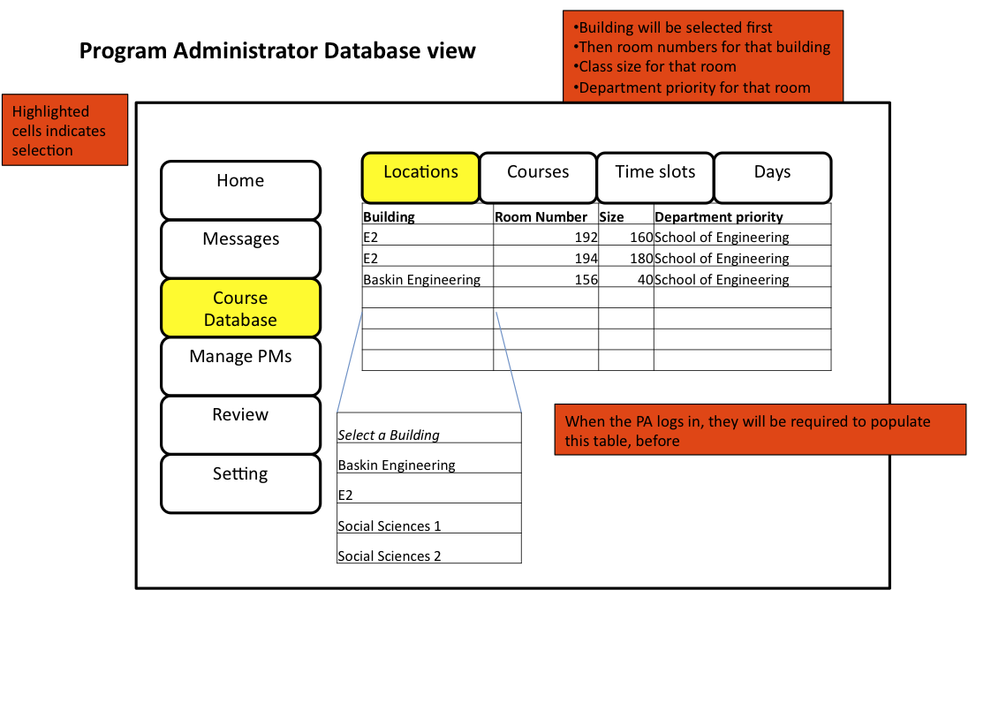
Figure 2.
The Program Administrator functions similar to any department user, of whom would be in charge of the overall MyCourses system and managing the database across all departments.
- You will need to sign into the browser-based MyCourses Portal with your username and password. (As shown in 2.1)
- Once logged in, as shown in Figure 2, you will enter your MyPortal. A notice will pop up indicating that the database needs information to be filled in order to continue.
- When clicking on Course Database, it opens an empty table in a spreadsheet format.
- The top of the table requires will need the following information:
  - Under Locations tab, a list of all classrooms and buildings available.
    - Building, room number, size, and department priority.
    - You will need to enter each classroom organized by building. (i.e. (building) Baskin Engineering → (classroom) BE156) Also room number, size, and department priority.
    - Subject preference. (i.e. Social Sciences belong with Sociology)
  - Under the Courses tab, enter list of all the daily courses during the quarter/semester.
    - This will be submitted separately into a database table by the Program Manager. (Computer Science → CMPS115)
    - Initially, each of the classrooms will be completely free and available unless otherwise noted.
  - Under the Time Slots and Days tabs, enter time slots and dates respectively, available to all the classrooms.
    - You will need to fill each section with a certain time. (i.e. (day) Monday Wednesday, and Friday)
    - Under the Days tab, enter a list of times for the courses offered.
- Once the information has been filled, Click Submit and the information will be stored. The Program Manager can then start determining which courses to offer for the next quarter/semester.

2.3 Program Manager
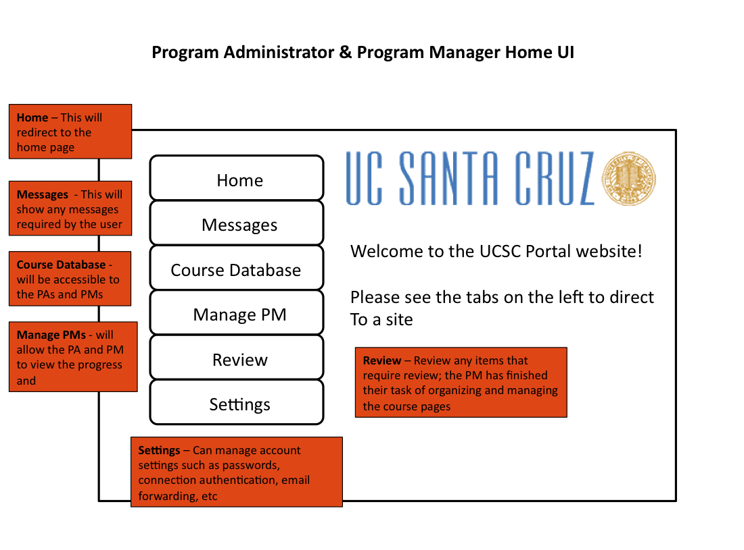
Figure 3.

This will be an outline for you, the Program Manager, and the MyCourses site. For this particular system, there needs to be multiple Program Managers, each are segregated into varying subjects (i.e. art, computer science, economics) and this section is dedicated to each Program Manager. At this point, the Program Administrator has sent in the constraints and you will be preparing your end for the Lecturer and Student.
- You must first sign into the browser-based MyCourses Portal with your credentials. (As seen in section 2.1)
- In the MyCourses Portal, you will notice it is similar to the Program Administrator page (as seen in Figure 3). By clicking on Messages, you will see messages from the Program Administrator or Lecturers. When clicking on Course Database, you will notice that this database is usable by both the Program Administrator and you, to fill out the tables. In the Review Tab, you will be able to review your accomplished tasks and organizational jobs.
- Once logged in, a message will pop up exclaiming that the database is ready for information about the current quarter/semester. You should then open the database of all listed courses for your specific department, chosen by the Program Administrator.
  - This database will list all of the courses in your department, offered at your institution.
    - The course list will be displayed in a table-like interface and will highlight upon selection.
    - Selecting each available course will indicate that the course will be offered for this quarter/semester.
  - Upon selecting the Lecturer for the course, another small table will pop up next to the selected course and you will be able to select which Lecturer to teach each course.
    - The table will display all available Lecturers currently in the department.
    - It will also place the Lecturers that have previously taught the course at the top of the table for reference.
- You may then select and highlight possible Lecturer candidates to teach your specified course for the current quarter/semester.
- When finished, you must click the “Submit” button and the courses selected will be stored onto another table in the database titled: Current Quarter/Semester, Year. (i.e. Fall 2010)
  - At this point, the table is ready to be reviewed upon completion of the table of the Lecturer constraints.
  - Once the Lecturer has submitted their constraints, the submitted database will be submitted for approval by the Program Administrator

2.4 Lecturer
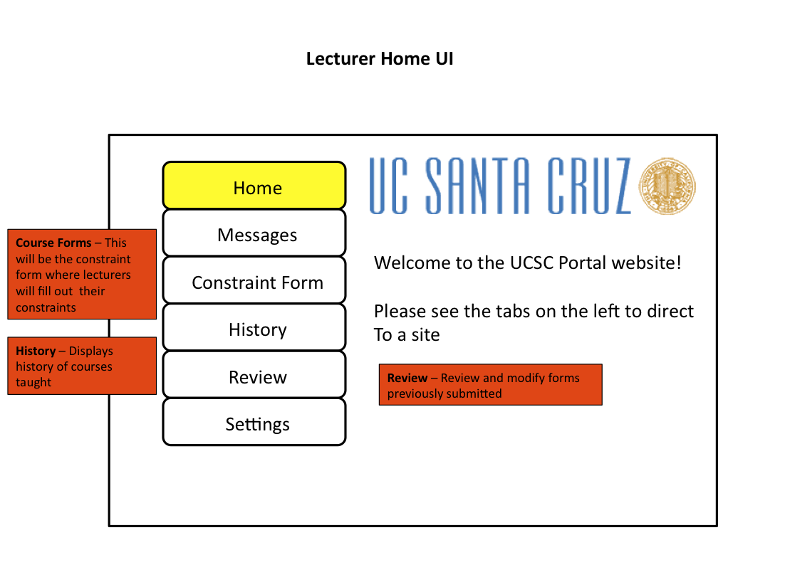
Figure 4.
When you first log into the MyCourses System before the new quarter/semester begins, you will have to submit constraint information for the system. As depicted in Figure 4, you need to click on Course Forms.
- First, you need to sign into the browser-based MyCourses Portal with your username and password. (As shown in 2.1)
- Once logged in, a message will pop up, indicating that you have not yet filled out your personal information for your constraints for the quarter/semester and therefore, must complete it to continue using the MyCourses portal
- Clicking on the Course Forms tab, leads to a set of constraints. This is similar to the Program Administrators database page (Shown in 2.2), which includes in pull down-menu-style:
  - Under the Courses Tab, you will be able to view the courses available, predetermined by the Program Manager. From here, you must choose from the multiple courses available.
  - Under the Time Tab, you will be able to choose the preferred time slots available, according to your personal schedule that quarter/semester.
  - Under the Days Tab, you will be able to choose the day slots available from the Program Manager.
- Once this form is completed, click Submit and the form is sent into the database where it will await for future approval from the Program Administrator.
- Once this is sent, you may click Messages, where you will find messages from either the Program Manager or Program Administrator. By clicking History, you will see the history of classes you’ve taught in the past and by clicking Review, you will be able to modify forms you’ve previously submitted. Lastly, Settings allows for a plethora of options to customize and make the Home UI easier for future use.

2.4 Student
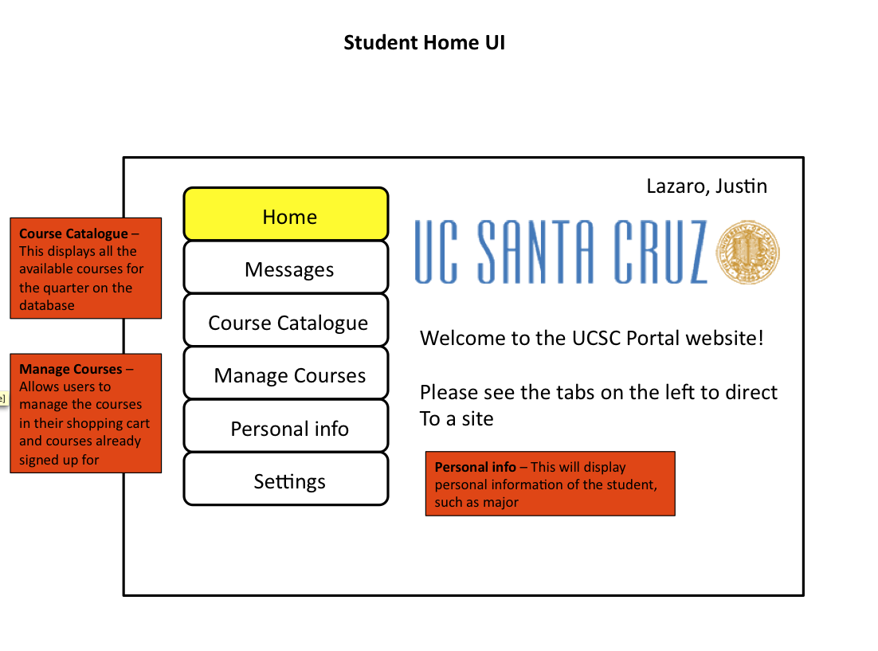
Figure 5.
By this time, the MyCourses Scheduling System is complete and posted on the website. The students can now log into the system and sign up for classes.
- As the student, you must log into the MyCourses Portal (As shown in section 2.1) and from there will immediately notice that you can sign up for classes. (As seen in Figure 5) By clicking on Course Catalogue, you will see the available classes for the quarter/semester, complete with professor, room number, dates, and specific times. The Personal Information tab will display information, such as type of major, year, transcript, and more. The Messages tab shows information from either a Lecturer or the Program Manager, describing any changes or updates in the scheduling system.
- Once clicked on Manage Courses, a pull-down menu is then initially shown, (as seen in Figure 6) providing information as to which subjects are available this quarter/semester. Right beside that is a table of courses selected along with the professor with times and dates.
  - This table next to the pull-down menu will be known as your Shopping Cart. You may select the classes of interest, drop them in your Shopping Cart, and decide with time whether you want to take them or not.
- Before you may peruse classes in your Shopping Cart, you must first choose which classes you would like to take, and this can be done by going into the Course Catalogue section, deciding the preferred class, and clicking Add Course.
- Once all classes have been chosen, your Shopping Cart will be full and after deciding which classes are wanted, you can click Submit to sign up for classes.
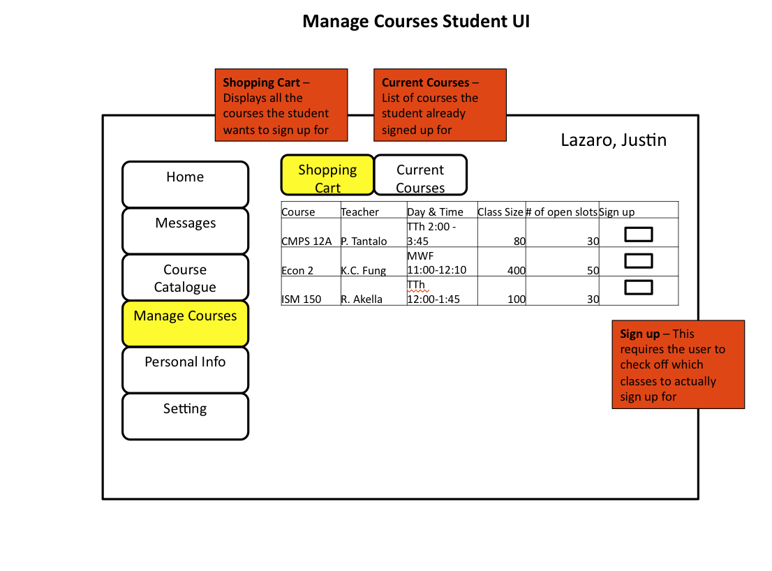
Figure 6.

Index

…

